Instructor Michael Buckhoff
S.T.E.A.L.T.H., The 7 Step System to Pass the TOEFL iBT
Online TOEFL Subscription Service
E-mail: michael@csusb.edu
Hi, this is Michael Buckhoff, founder and materials writer for the 7 Step System to Pass the TOEFL iBT. You may been wondering what S.T.E.A.L.T.H. means; it is acronym which stands for seven essential steps to pass the TOEFL iBT: Super-Size Your Vocabulary, Target and Improve Your Pronunciation Weaknesses, Evaluate Your Grammar Competencies, Analyze Your Listening Strengths and Weaknesses, Learn Effective Reading Strategies, Target and Improve Your Writing Weaknesses, and Have an Organized Approach to Speaking.

To get the most out of this subscription service, I advise that you complete the 7 Step System in the order that I have designed it. For example, complete all the lessons in step 1 before going to step 2, complete all the lessons in step 2 before going on to step 3, and on and on and on.

Each step in the 7 Step System will be explained so that you will know how to effectively use my subscription service. Please read all the information contained in this document BEFORE beginning my service.

Step 1: Super-Size Your Vocabulary

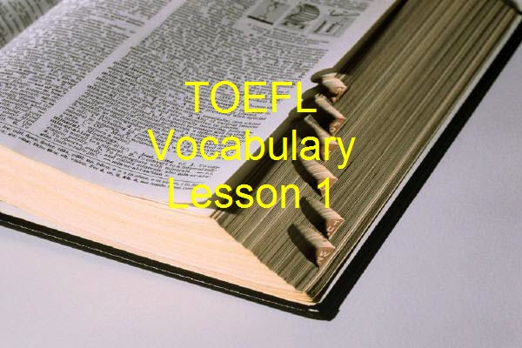
The first step to successfully pass the TOEFL iBT Exam is building vocabulary proficiency. Let’s face it. How can you understand college level vocabulary without having basic vocabulary? Moreover, how can you perform optimally when reading and listening to TOEFL iBT passages without a good vocabulary foundation? Finally, how can you support your generalizations on the speaking and writing sections with details without having practiced vocabulary beforehand? For example, if you are asked to summarize a lecture about mountain ranges in the United States, will you have sufficient vocabulary to accurately and intelligently complete the speaking or writing task? Be sure to keep in mind the following about the lessons in this step:

Print Vocabulary Lesson 3, a 150 page basic vocabulary E-book, and complete all the chapters, unit tests, and comprehensive exams offline (However, you will NOT be able to practice the listening exercises offline).

You should aim to score 85/100 on the two comprehensive exams before moving on to Vocabulary Lesson 4.

Create a note-card study system in which you put each word in each lesson onto a note-card with the word on one side and the definition and sample sentence on the other.

Make audio recordings of the words from each lesson saying the following: the word, the definition, a sample sentence, and any other relevant information that will help you to remember the word.

Over a period of a few weeks, as you study the words from Vocabulary Lesson 3 using your note-card system, you should also listen to the words on a musical device. Study the words until you are comfortable using them in your speech and writing.

Print all materials for college-level Vocabulary Lesson 4, which can be thought about as having three alphabetically-arranged sections: A-E (500 words), E-P (500 words), and P-Z (500 words). Complete the units tests and final exams offline.

You should aim to score 85/100 on the final exam for the A-E section before moving on to section E-P and to score 85/100 on section E-P before moving on to section P-Z.

As you did in Vocabulary lesson 3, create a note-card study system, this time for 1,500 words.
Also, though there are audio recordings that you can download for each section of this lesson, I recommend that you make your own recordings focusing on the following: the word, the definition, a sample sentence, and any other relevant information that will help you to remember the word.

Like Vocabulary lesson 3, you should study these words using your note-card study system and listening to the words on your portable musical device.

Step 2: Target and Improve Your Pronunciation Weaknesses

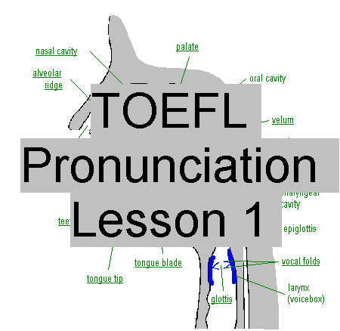
The second step to successfully pass the TOEFL iBT Exam is having intelligible pronunciation. In other words, when you speak English, can a native speaker understand what you are saying without being distracted by awkward pauses and unclear pronunciation, perhaps due to enunciation problems with vowel and consonant sounds. After all, if the human raters can not understand what you are saying, how can they give you a high score on the TOEFL iBT speaking? Keep in mind the following about the lessons in this step.

Before recording your pre-tests and post-test for the lessons in this step, you will need to ask approval from me (mbuckhoff@aol.com) to join my Voxopop discussion group, an exclusive web portal. Kindly send me an E-mail stating that you are a S.T.E.A.L.T.H. student and that you want to join my discussion group so that you can complete the Speak Clearly pre-tests and post-test.

Take the Vowel and Consonant Sound Pre-Test, even if you think you do not need to.

Do not forget to use the use the link “See and Hear How Vowel and Consonant Sounds Are Produced.” And, while doing so, place a mirror next to your computer so you can see yourself imitate the sounds made by the speaker. Particularly, focus on the problem sounds from your diagnostic pre-test.

Take the syllable division, grammatical word endings, word stress, sentence rhythm, intonation, thought groups, and blending once you feel you have mastered all the previous lessons in this step.

Though I will make recommendations on which lessons you should focus, you should study all the lessons in this step, making sure that you complete the practice exercises at the end of each lesson.

As you watch each video lesson, you should read out loud with me, a technique called tracking. This will be difficult for you at first, but keep at it—even though your tongue, lips, and mouth will become tired. In time, you will be able to read with me at the same pace, with the same stress, intonation, and pausing. And your mouth will eventually get used to the new sounds.

Since a lot of the content in each video is academic in nature, you can also practice your integrated speaking and writing skills by taking notes on the main points of the reading passages (or lectures if you choose not read them). Finally, using your notes, you can practice writing a summary or orally summarizing the content. Doing this during this step will prepare you for the integrated writing and integrated speaking lessons that you will take later on.

Finally, upon completing all the lessons in this step, take the post-test. Your goal is to score 5.0/7.0, meaning that you have a barely detectable accent. If you can score 5.0/7.0 or higher on my intelligibility post-test, TOEFL iBT human raters will not be distracted by your accent, allowing them to focus on your organization, topic development, word choice, and grammar (You will learn about organization and topic development when you get to the last step in the 7 Step System: speaking). More importantly, a score of 5.0 or higher guarantees that your English-speaking friends, professors, co-workers, or supervisors will be able to understand what you are saying.

E-mail me (mbuckhoff@aol.com) when you have completed a pre-test or post-test, and I will score it as soon as possible.

Step 3: Evaluate Your Grammar Competencies

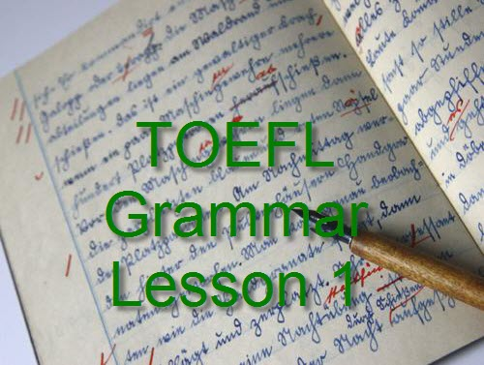
The third step to successfully pass the TOEFL iBT Exam is learning basic and advanced sentence structures, verb tenses, word forms, word choice, parallel structures, and so on. Think about the importance of grammar. A car cannot run without its engine, right? Most certainly, a language cannot exist without its grammar. Without having knowledge of grammar, you will be limited in your reading, listening, speaking, and writing skills. As you complete the lessons in this step, keep in mind the following:

Do not go to the writing and speaking steps without having completed the grammar lessons in this step.

After studying sentence variety, being more concise, and punctuation, all contained in Grammar Lessons 1-3, you should click on the link titled “Writing, Grammar, ESL, and Research Exercises.”

After clicking on the “Writing Exercises” link, complete all of the following: purpose and audience, thesis statements, introductions, choosing an appropriate point of view, topic sentences, and transitions.

Then, click on the “Grammar Exercises” link and focus on the following: sentence style, word choice, grammatical sentences, ESL challenges, punctuation, mechanics, and research exercises (after which, choose the “Researching [general] option).

It is critical that you not only complete these writing, grammar, and research exercises but also understand what you are being taught, for learning this content will better acquaint you with the rigors of academic writing, better preparing you for the independent and integrated writing sections of the TOEFL iBT. Above all, you will also learn to minimize the frequency of grammar errors that you are making when you speak and write English.

Step 4: Analyze Your Listening Strengths and Weaknesses

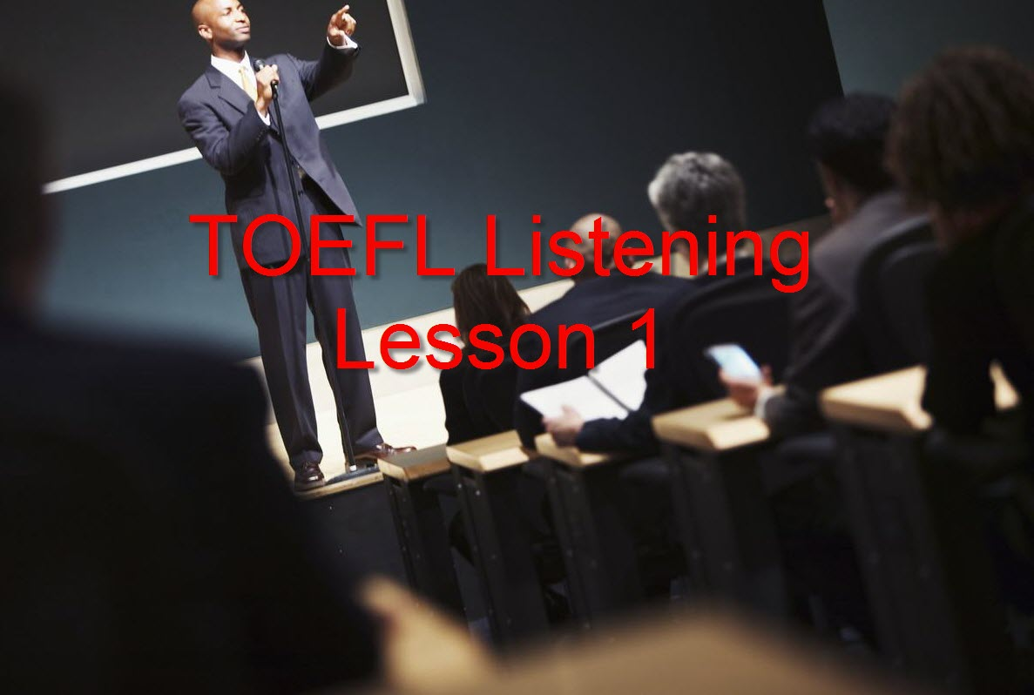
The fourth step to successfully pass the TOEFL iBT Exam is learning to catch the main idea and important details of campus-related and academic listening passages. As you know, the TOEFL iBT has campus-related and academic discussions and lectures in the listening, speaking, and writing sections of the TOEFL iBT. If you have “slow” ears or you can not concentrate when listening to TOEFL iBT passages, you are guaranteed a low TOEFL iBT score. Keep these tips in mind as you complete these lessons:

After learning how to take notes and after understanding the characteristics of natural speech, you should practice taking notes as you complete the listening practice tests in this step. You can use your notes to answer the comprehension questions.

Developing a note-taking system during these lessons will make it easier for you to complete the integrated and writing TOEFL iBT tasks, so make sure you complete these lessons before going on to the writing and speaking lessons.

Also, you should use your notes to write and give oral summaries of the lecture to which you listen. This will help prepare you for the integrated writing and speaking lessons in steps 6-7 of my 7 Step System to Pass the TOEFL iBT.

Step 5: Learn Effective Reading Strategies
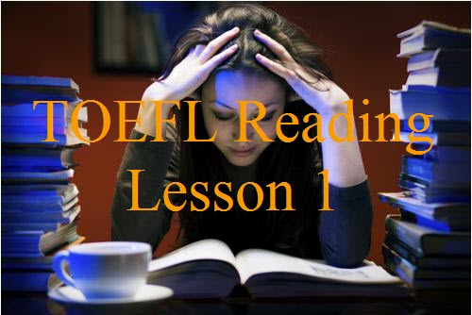
The fifth step to successfully pass the TOEFL iBT exam is learning effective reading habits, discerning main ideas and details, keeping a reader response journal summarizing what you have read, understanding vocabulary from context, understanding the organization of reading passages including transitions, and having the ability to make inferences. Moreover, since you will have reading passages on the reading, speaking, and writing sections of the TOEFL iBT, being a proficient reader with an ability to concentrate well and having a good reading speed is more important than ever. If you cannot discern main ideas from support ideas and if you cannot separate important details from trivial ones, it will be difficult for you to succeed on the TOEFL iBT. Here are some things you should consider as you complete this step.

The first lesson will teach you how to read academic passages and how to take notes of these passages so that you will be able to create organized responses during the integrated writing and integrated speaking tasks.

The other lessons are designed to familiarize you when the TOEFL iBT question types you will see during your TOEFL iBT exam: vocabulary, pronoun referent, paraphrase, insert a sentence, details, negative detail, implied detail, infer rhetorical purpose, summary chart, and schematic table questions.

In addition to the lessons learned in this step, you will also need to engage in an extensive reading campaign in which you regularly read for about 45 minutes daily. A good start is National Public Radio, an online nonprofit news service featuring news articles and audio recordings. Go to the site every day and do the following:

Read a news article, take notes on the main points of the passage, and then read the comments from other readers. These readers typically will express political opinions on the articles. Your goal is to respond to at least 3 comments from each article you read. Doing this helps you to think about what you read and to express your opinion about what you read to others. Engaging in critical thinking, you will better prepare yourself not only for the reading section but also for the integrated speaking and writing sections of the TOEFL iBT.

Continue to regularly read each day until you can read from a computer screen at a speed of 300 words per minute with 80% comprehension. There are many free speed reading tests on the Internet that you use to test your speed and comprehension. Included below are five such tests:

Free Reading Test by Acereader

Speed Reading Test Online by Readingsoft

Free Online Speed Reading Test

Free Speed Reading Test by Short Burst Learning

Speed Reading Test

Finally, successfully completing the lessons in this step is dependent on your

Having successfully completed vocabulary lessons in step 1, resulting in a mastery of both basic and college level vocabulary---or 1,700 words.

Having practiced extensive reading over a period of time until you have achieved a consistent reading speed above 300 words per minute from a computer screen with approximately 80% comprehension.

Understanding the TOEFL iBT question types (1) by being able to identify each question type and (2) by being able to apply the correct test-taking reading strategies for that question type.

Step 6: Target and Improve Your Writing Weaknesses

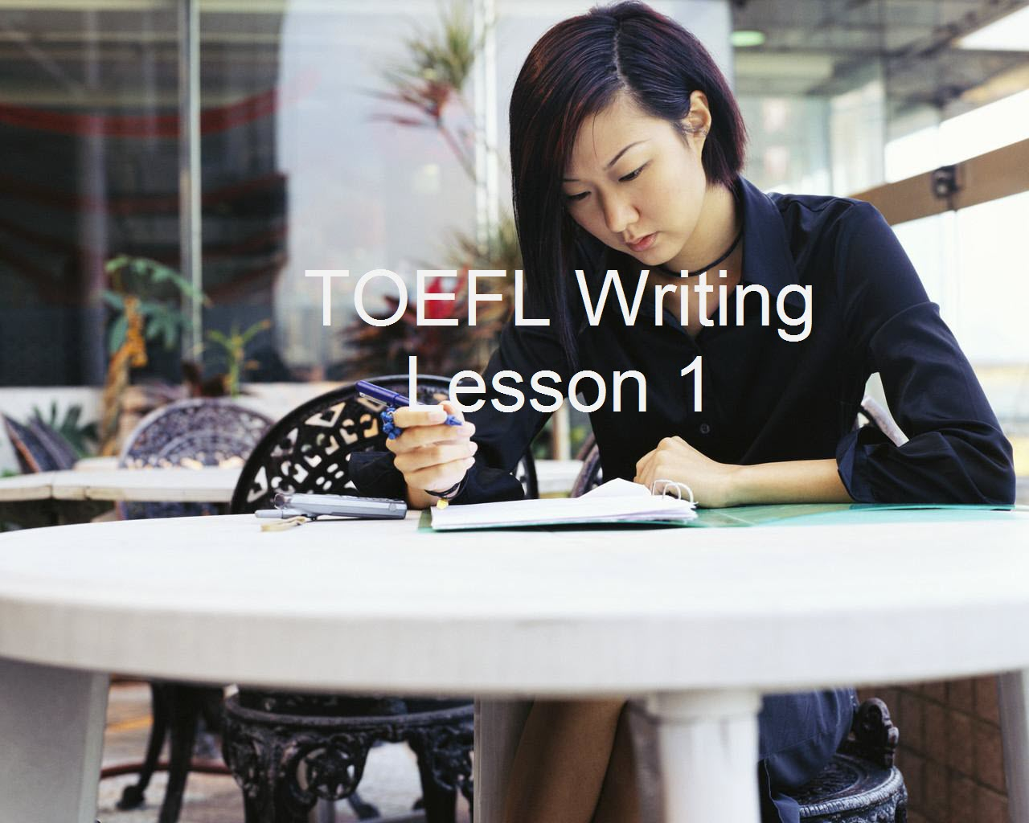
The sixth step to successfully pass the TOEFL iBT Exam is to gain competence in independent and integrated writing skills: decoding the writing task, organizing a coherent response, writing detailed developmental paragraphs, and ending the essay with a conclusion. In the case of the integrated writing task, your goal is to coherently and accurately connect the reading and listening passages together by writing a 150-250 word response. Before beginning this step, keep in mind the following:
First, make sure that you have completed the vocabulary, grammar, and reading steps before this writing step. Second, complete all the appropriate writing lessons before taking an independent writing practice test.
Each practice test has a time limit, the first three of which have limits of 45, 40, and 35 minutes respectively. Giving you extra time in the first three practice tests will allow you to slow down a little and practice what you have learned in the lessons leading up to the practice test.
Then, with practice tests 4-10, you can practice writing under “test” conditions with a 30 minute time limit.
Once you complete a practice test, click “Submit all and finish,” at which time I will “see” your response. If you click “Submit,” I will not see your response. Please E-mail me at mbuckhoff@aol.com to let me know that you have completed a practice test (Be sure to tell me which number) and that it needs scoring.
I will score your practice test according to the TOEFL iBT rubrics for the independent writing task. Do not take another writing practice test w/o having gotten comments from a TOEFL iBT writing specialist on the previous practice test.
You will have successfully completed this step when you can consistently score higher than 4.0/5.0.
Complete the appropriate integrated writing lessons before taking a practice test.
Like what you did with the independent practice tests, click “Submit all and finish,” E-mail me at mbuckhoff@aol.com to let me know the number of the practice test you need me to score, and I will score the test according to the TOEFL iBT rubrics for the integrated writing task. Please do not take another practice test until you have received a score plus comments.
You will have successfully completed this step when you can consistently score 4.0/5.0 or higher on the TOEFL iBT.
Step 7: Have an Organized Approach to Speaking

The seventh step to successfully pass the TOEFL iBT Exam is learning competent speaking skills: decoding the speaking task, organizing a coherent response including a topic statement, delivering rich details in the body of the speech, and ending with a conclusion. Despite your preparedness, you will have difficulty on the speaking section, but, if you have completed all the prior steps to this “7 Step Program to Pass the TOEFL iBT Exam!”, you will have the vocabulary, pronunciation, grammar, listening, and reading proficiencies that will be crucial elements in helping you to score high in TOEFL iBT speaking. Additionally, after having completed the writing lessons in step 6, you will have the organizational skills that you can transfer to your speaking proficiencies. To maximize your success with the lessons and the practice tests in this step, keep in mind the following recommendations:

Be sure that you have completed all the steps before attempting the lessons and practice tests in this step, including

An 80% mastery of the vocabulary words in step 1

A final score of 5.0/7.0 or higher on my intelligibility and speaking post-test in step 2

An average of 80% or higher on the listening practice tests in step 4

A reading speed of at least 300 words per minute in step 5

Complete all the independent and integrated lessons before taking an independent or integrated speaking practice test.

Before taking a speaking practice test, you will need to ask approval from me (mbuckhoff@aol.com) to join my Voxopop discussion group, an exclusive web portal in which you can complete ten independent and ten integrated speaking practice tests. Kindly send me an E-mail stating that you are a S.T.E.A.L.T.H. student and that you want to join my discussion group so that you can complete the speaking practice tests for the 7 Step System to Pass the TOEFL iBT.

E-mail me (mbuckhoff@aol.com) when you have completed a speaking practice test, and I will score it as soon as possible.

Once you have completed the lessons and practice tests in my 7 Step System to Pass the TOEFL iBT, you will be ready to take the TOEFL iBT. Once you have taken the TOEFL iBT and get your results, please come back and make a comment at http://www.bettertoeflscores.com letting me know how you did.

Michael Buckhoff

